Apr 11 Trading

Opening is very bullish. Bought on Thursday on the worst time, sold on Friday at the worst time.

Situation is kind of tricky now. I do not want to chase here, but if the market retreats, it will be a good buying opportunities for the CL.

Market is very resilient trading at a premium. As of 9:45, market is trading @ a 20 bps premium, signifying the strength of the move. A lot of long position have been built between 9:30 to 9:40.

The mistake from last week is buying too early on Thursday, should have bought on Thursday Close and held through the weekend with at least 1 lot as what you would usually do.

Having a large position on Thursday caused the panic and the position to be prematurely sold on Friday. The reason you made money was that you insisted on buying on day's lows. Now I have no cost advantage and I will not chase. I will only build position when my cost advantage is better than everyone in the market. This is important in the long run.

Buying at the lows proved to be effective in the first three months of the year and we need to build on this progress instead of annulling it. Most people are long and making money at this point, I have no cost advantage -> no entrance.

Markets continuously trade at a premium and quickly go into euphoria.

It is important to be emotionless about market movements, having position or not should not affect market perception and probability.

Looking at the 1 week line, now it is not a good entrance point, it looks more like a selling point. Last Friday during the afternoon panic was a good buying point. The amMinT pushed it to that point and pmFirst10 pulled it back up. Then having 2 lots through the weekend would have been nice.

Selling is equivalent with shorting and it should not be done in the AM session unless it is Thursday or Monday with both negative retOPC and amFirst10.

Of course, no shorting is allowed on a day like today, where both retAMCO and retPMCO >0. RetCH is a pathetic -48 bps.

Bought 1 lot @9635, this is not a good level but entered anyways.

What has been done in the last few days are canonical examples of bad trading. However, you must be able to experiment and learn the techniques of early chasing and probability trading and expand the original scope of only buying at the lows.

Towards the end of this session, the position is losing 60 bps. This trade is justifiably very bad. It is chased near 10:15, the highest unrealized profit on this trade was less than 30. I was footing the bill for the market today.

This is the trading skills demonstrated within the last three trading days.

Learn the lesson and do not chase trades. Make sure you have pre-existing position on Monday, Wednesday and Friday and you are allowed to get rid of the position on these days. Do not chase though. Make sure to pick up positions only at the day's low.

Mon/Wed/Fri: do not sell at the day's open.

Tues/Thurs: Thurs: sell at day's open.

**Revert to the conservative trading method of no chasing, only buy if at day's low.**

Couple this with the recent research results, when the research results are consistent with common sense.

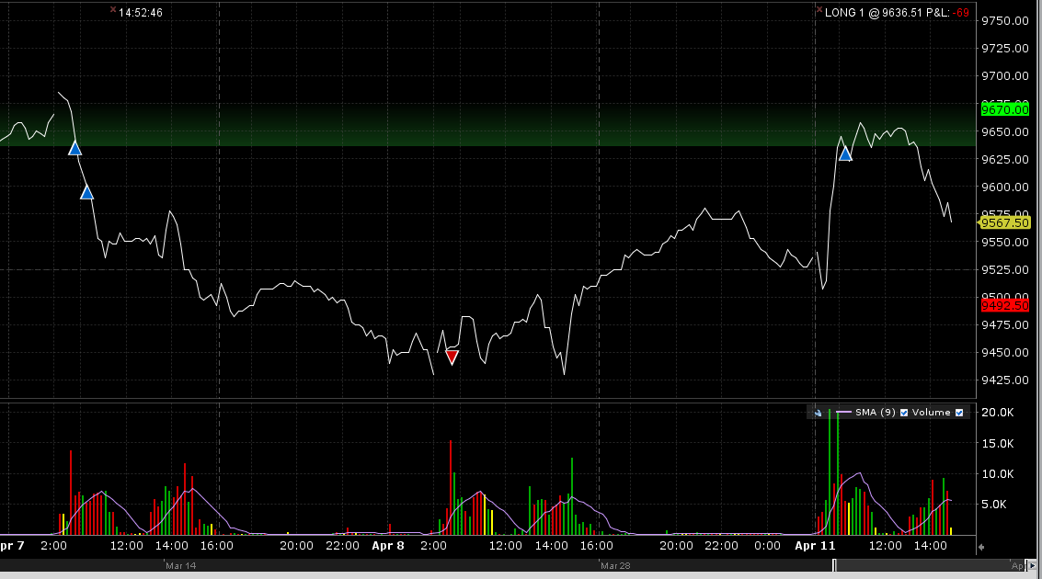

Day traders massively reduce position into the close, pushing the index to -0.5% discount. This is taking into account tomorrow's low open. The position is now bleeding 90 bps.

The expected return from chasing is negative, be very careful. One would only have made money today if entering @ 9:30. This is the normal requirement where only 20% of market participants make money.

It is not feasible to hold the position to the end when the position was entered by chasing high. Learn the lesson and move on.

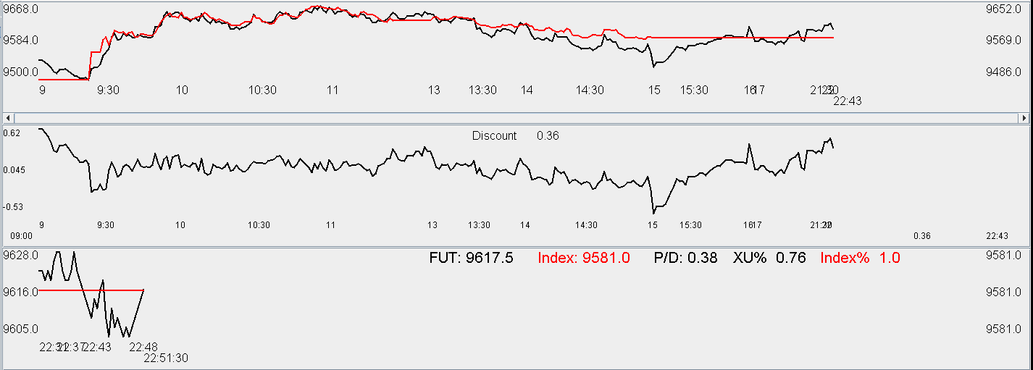

**4.12.2016**

In retrospection of recent trading, I have come to realize that new research has resulted in excessive complacency which is reducing caution, causing performance to slip.

Stick to the original methodology of no chasing. Stick to low positioning.

Things that you should do the same

1. low positioning
2. never to chase

The only thing you should do differently at this moment is

1. Thursday no long, eligible for short if previous day > 0.8.
2. Monday, Wednesday build position if opens high.
3. if opens high+amfirst10>0, can add position if index achieves daily low
4. Monday, Wednesday and Friday no shorting.
5. Tuesday is eligible for shorting if opens up and yesterday ends above 80% percentile.

Keep in mind:

**The only reason you had made money throughout the first three months is because you always bought at the lows (at that time) and sold at the highs**. Make sure to continue to do this. These principles cannot be compromised just because of new research results.

Yesterday, position was built at 10:15 which was way too late on a Monday. Position needs to be built at day's open if amFirst1>0 and retOPC>0. As can see from the retCO distribution below, first minute rising shifts the distribution considerably to the right.

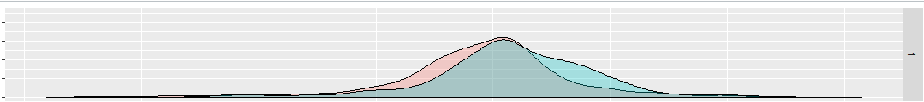

Average CO today is 40 bps with CL 1.28%.

If it drops further, it would be good to pick up some position, otherwise hold until the end.

Futures are trading at a premium, which shows the underlying bullishness.

A lackluster session.

Research indicates that the previous day closing percentile has a significant impact

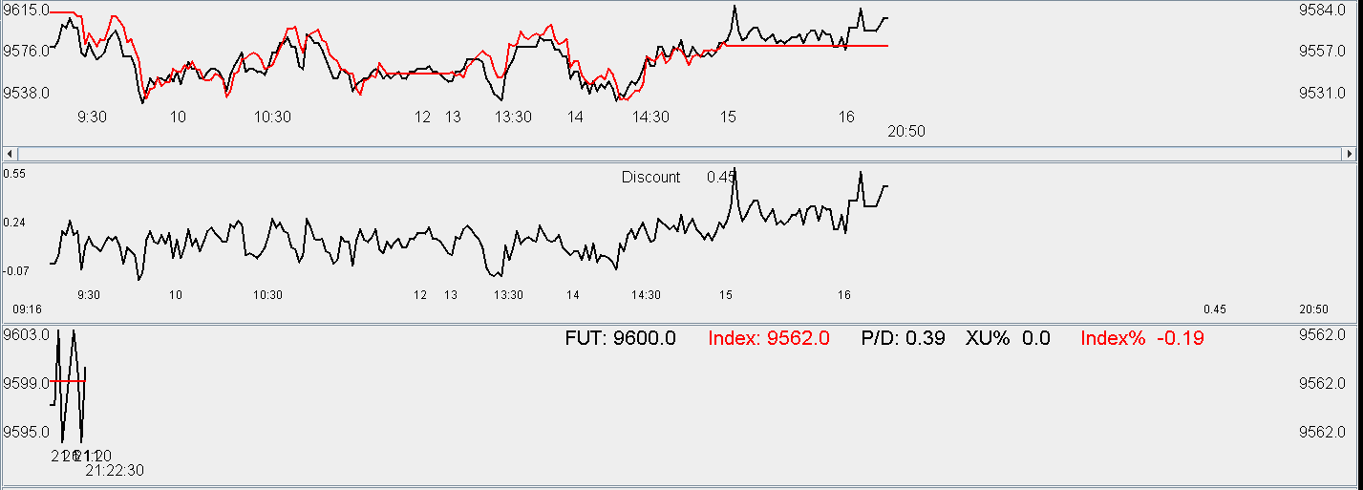

Today's research results include that retCO is statistically different with different percentileY.

Monday benefits from high percentileY from Friday.

Tuesday and Thursday are hurt by high percentileY from Monday and Wednesday.

Wednesday is not affected by Tuesday.

One mistake made last Thursday was that given a strong (>80%p) Wednesday, position was entered on Thursday, it was an apparent mistake in retrospect. In addition, with Thursday closing at the lows, position should have been held to the end of day Friday, which was not done.

The issue with the positioning last week was because an error was made on Thursday and the positioning was too heavy. Punishment occurred on Friday morning and caused the liquidation of the position. When T-1 closes in the bottom 20% percentile, the next day has positive return.

Today's end of market pull was expected as both amLast15 and pmFirst10 are positive.

Futures is trading at a premium which reflects the expectation of a positive retOPC tomorrow.

Add 1 lot to the existing position if tomorrow opens high.

4/13

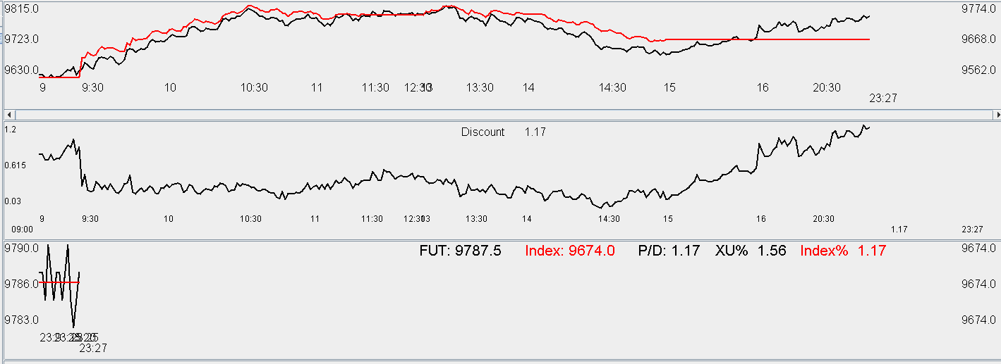

Markets are strong today. Still trading at 1.17 premium.

Short tomorrow morning.

4/14/16

Shorted in the morning @ 9800, covered at 9750. This covering might have been too early. Markets are still breaking lows.

The last 15 minutes of the am session was weak but the afternoon open was rather strong.

Afternoon price action is quite confusing. XU gave back all of its premium and the index is roughly unchanged. The open

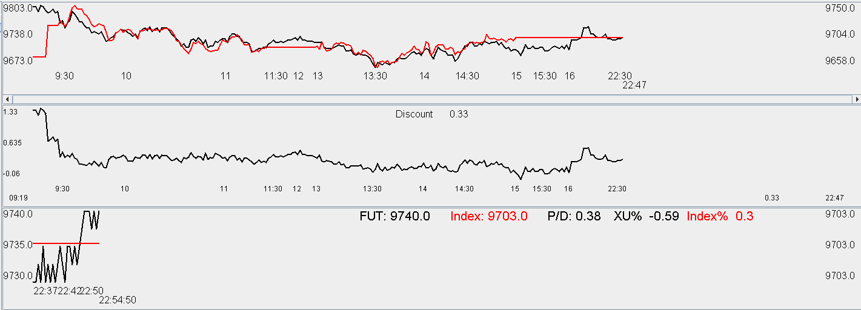

4/15/16

Morning min broke after 10. It is no longer a good choice to buy here as the conditional expectation of the amMin is in after 10.5.

1047 update

Markets are not active. Very low trading volume today. Nothing much to do.

Weekly update:

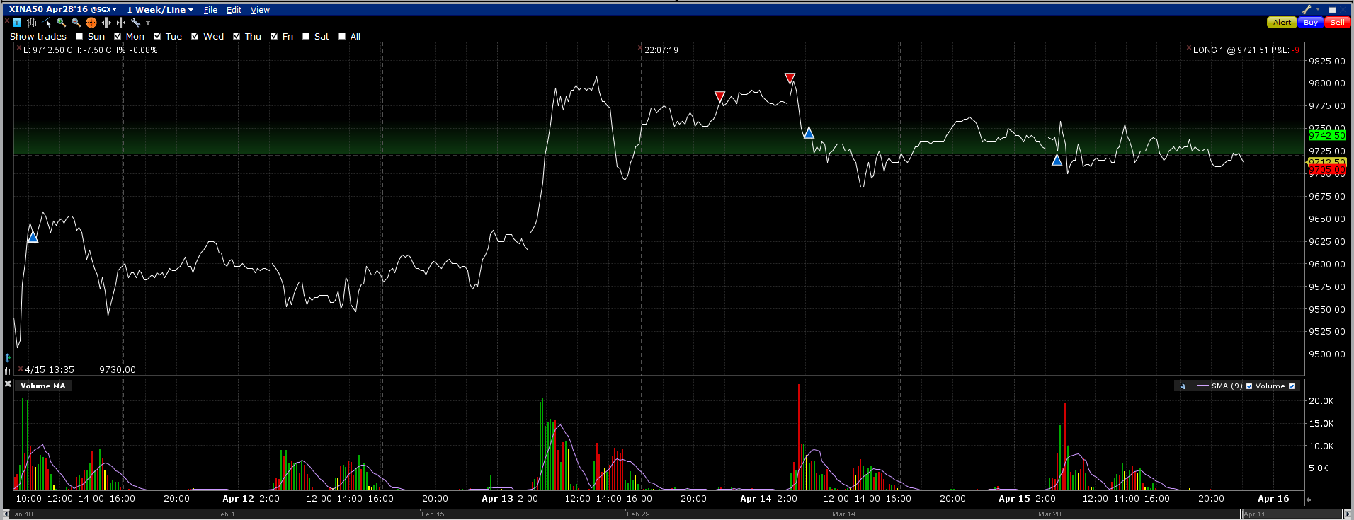

Monday: position building needs to be earlier with a high retOPC when there is no position at all. The entrance was too late. Entrance at 9:25 first thing when return OPC is out. Note that if the retOPC is down then cutting position to a bare minimum is required. Monday given the nature

Tuesday: there was a chance to pick up position towards the end of the market.

Wednesday: Entry at today's opening and sell in early PM.

Thursday: Well done. Hold the short longer until early PM.

Friday: nothing to do. Hold position to next Monday.